OES Ladder Safety Plan

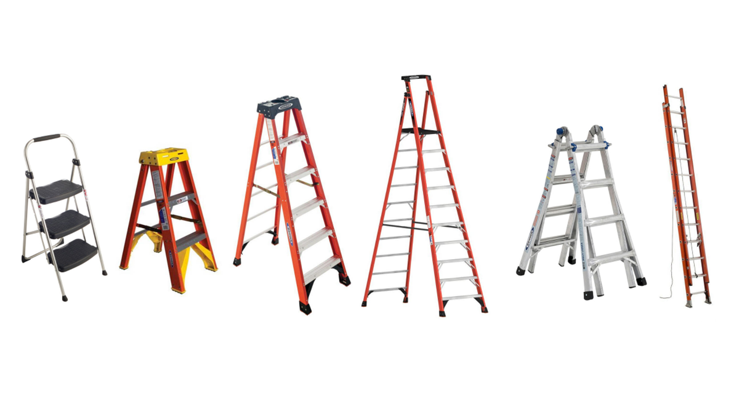

Contents

PURPOSE 3

SCOPE 3

DEFINITIONS 3

RESPONSIBILITIES 4

LADDER CONSTRUCTION REQUIREMENTS 6

REFERENCES 8

POINT OF CONTACT 8

OES Ladder Safety Plan

1.0 Purpose
Ladders are effective tools to help employees work at heights. While ladders seem easy to use, they should not be taken for granted. It’s important to know that employees who work on or around ladders risk permanent injury or death from falls and electrocutions. Ergonomic injuries while lifting, carrying, and handling ladders are also possible.
Clemson University (CU) is dedicated to the protection of its employees, as well as contract and temporary employees, from on-the-job injuries. This written Ladder Safety Plan lists the ladders we have onsite, provides inspection procedures, describes the safe practices for the care and use of ladders, and standardizes the training of employees.
2.0 Scope
This written plan demonstrates our compliance regarding the many different types of ladders. When the word “employee” or “employees” is used in this plan, it is to include not only our own employee(s) but also contract and temporary employee(s). The procedures in this plan are to be followed whenever an employee works with ladders at our worksite(s).
3.0 Definitions
The Occupational Safety and Health Administration (OSHA) defines a ladder as a device with rungs, steps, or cleats used to gain access to a different elevation.
Combination Ladders – A portable ladder capable of being used either as a stepladder or as a single or extension ladder. It may also be capable of being used as a trestle ladder or a stairwell ladder.
Extension Ladders – A non-self-supporting portable ladder adjustable in length. It consists of two or more sections traveling in guides or brackets as to permit length adjustment.
Fixed Ladders – Cannot be readily moved or carried because they consist of rails or individual rungs that are permanently attached to a structure, building, or equipment. Fixed ladders include individual-rung ladders, but not ship stairs, step bolts, or manhole steps. Employees may need to step sideways from a fixed ladder (a side-step ladder) or through the side rails (a through ladder) at the top to reach a walking-working surface, such as a landing.

Ladder – A device incorporating or employing steps, rungs, or cleats on which a person may step to ascend or descend.
Ladder Safety System – An assembly of components whose function is to arrest the fall of an user, including the carriers and its associated attachment elements, safety sleeve, body support and connectors, wherein the carrier is permanently attached to the climbing face of the ladder or immediately adjacent to the structure.
Mobile Ladder Stand – A mobile ladder stand, or ladder stand means a mobile, fixed-height, self-supporting ladder that usually consists of wheels or casters on a rigid base and steps leading to a top step. A mobile ladder stand may also have handrails and is designed for use by one employee at a time. A mobile ladder stand platform means a mobile, fixed-height, self-supporting unit having one or more standing platforms that are provided with a means of access or egress.
Platform – A landing surface that is used as a working or standing location.
Portable Ladders – Can be readily moved or carried, and usually consist of side rails jointed by intervals by steps, rungs, or cleats. Stepladders, straight ladders, and extension ladders are all examples of portable ladders.
Rail – The side members joined at intervals by either rungs or steps.
Stepladder – A self-supporting portable ladder, non-adjustable in length, with flat steps and a hinged base.
Step stool – A self-supporting foldable, portable ladder, non-adjustable in length, with flat steps and without a pail shelf.
Working Length – The length of a non-self-supporting portable ladder measured along the rails from the base support point of the ladder to the point of bearing at the top.
Working Load – Maximum applied load, including the weight of the user, materials, and tools, that the ladder is to support for the intended use.
4.0 Responsibilities
1. Department
Maintenance, Inspection, Repair and Modification
Each department shall date and retain the following records:
- Maintenance: Each department is responsible for their own ladders. To ensure the safety and continued working condition of our ladders, we must invest time and effort into their proper upkeep, which results in day-to-day reliability. Keeping up with the manufacturer’s recommended maintenance schedules, as well as completing the proper records, will also increase our ladders’ longevity. Proper ladder maintenance ensures the safe condition of the ladder. Hardware, fittings, and accessories should be checked frequently and kept in proper working condition. All pivoting connections and the rung-lock cam surfaces should be lubricated frequently. All bolts and rivets shall be in place and secure before using a ladder, and no ladders shall be used if any bolts or rivets are missing or if the joints between the steps (or rungs) and the side rails are not tight. Ladders with safety shoes or padded feet which are excessively worn shall be taken out of service until repaired.
- Inspection: CU seeks to prevent injuries and fatalities caused by ladders simply by establishing an inspection process that identifies and addresses ladder safety and compliance concerns. A thorough ladder inspection shall be made when the ladder is originally purchased, received, and put into service. The ladder shall be inspected before each use. Working parts and rung/step-to-side-connections shall be checked. – Broken or bent ladders shall be marked and taken out of service until they are repaired by a competent mechanic or destroyed in such a manner as to render them useless. The user shall not attempt to repair a defective side rail.
- Repair: If any deficiencies are discovered during ladder inspections, or during any other time, the issue will be brought to the attention of their supervisor or manager. This individual is responsible for ensuring the ladder is:
- Tagged or marked for service.
- Removed from service until the hazard or defect is corrected or repaired.
- Examined for the extent of the reported damage, deficiency to determine whether it constitutes a safety hazard.
- Repaired, replaced, or disposed of, as necessary by the supervisor or manager.
- Put back into service is fully repaired and passes the ladder inspection.
2. Supervisors
Supervisors are responsible for ensuring employees have been properly trained before using ladders and that employees adhere to the provisions of this program. Supervisors will coordinate the maintenance, inspections, repairs, and modifications regarding the ladders within their departments.
3. Employees
Employees are responsible for selecting the appropriate ladder for the task, inspecting the ladder prior to use, and using safe work practices defined in this plan.
- The intended use of the ladder shall be restricted to the purpose for which the ladder was designed.
- The duty rating of the ladder must be clearly indicated on the ladder. The working load to be placed on the ladder including the person and tools must be less than the duty rating.
- Ladders shall not be climbed on by more than one person at a time unless designed to support more than one person.
- Stepladders shall not be used as single ladders or in the closed or partially closed position.
- The user shall not step or stand higher than the step or rung indicated on the label marking the highest standing level on a ladder.
- The user shall not step or stand on the ladder top cap and the top step of a stepladder, or a combination ladder configured as a self-supporting ladder.
- The rear braces of a stepladder may not be used for climbing.
4. Contractors/Vendors
Contractors and vendors shall be responsible for supplying their own ladders for use on campus.
5. OES
OES is responsible for developing and maintaining CU’s ladder safety program by providing training as necessary, maintaining training records, and by performing and/or coordinating inspections.
5.0 Ladder Construction Requirements
a. Fixed and portable ladders and step stools shall at minimum meet the appropriate Occupational Safety and Health Administration (OSHA) and American National Standards Institute (ANSI) A14.1 materials and construction specifications.
b. Newly installed fixed ladders that are 24-feet or longer shall be outfitted with a ladder safety system.
c. Existing fixed ladders that are 24-feet or longer must be retrofit with a ladder safety system prior to 11/18/2036.
d. Portable ladders shall display the appropriate legible ANSI standard compliance marking and other ladder safety markings. Labels/markings must be replaced when they are no longer legible.
e. Angle of inclination should be erected at a pitch of approximately 75 degrees from horizontal for optimum resistance to sliding, strength of the ladder, and balance of the climber. A simple rule for setting up a ladder at the proper angle is to place the base a distance from the wall or upper support equal to one-quarter the effective working length of the ladder. Effective working length is the distance along the side rails from the bottom of the support point of the upper portion of the ladder.
f. Footing support shall place the base of the ladder with a secure footing on a firm, level support surface. Ladder levelers may be used to achieve equal rail support on uneven surfaces. Devices such as shoes, spurs, spikes, combinations thereof, or similar device of substantial design should be installed where required for slip resistance and bearing areas. Where ladders with no safety shoes, spurs, spikes or similar devices are used, a foot ladder board or similar device may be employed. Ladders shall not be used on ice, snow, or slippery surfaces unless suitable means to prevent slipping are employed. Ladders shall not be placed on boxes, barrels, or other unstable bases to obtain additional height.
g. The top of a non-self-supporting ladder shall be placed with the two rails supported equally unless it is equipped with a single support attachment. Such an attachment should be substantial and large enough to support the ladder under load. It should be used when the ladder top support is a pole, light standard, or building corner, or in tree-type operations.
h. The side loading of portable ladders is not designed for excessive loading, and such abuse of the ladder shall be avoided. The ladder shall be kept close to the work. The user shall not overreach but shall descend and relocate the ladder instead. When using a ladder, the user shall never push or pull unless the ladder is properly secured.
i. When ascending or descending the ladder, the user shall face the ladder and maintain a firm hold on the ladder. It is preferable to grasp the rungs with an overhand grip as opposed to grabbing the rails. Grip strength is improved while grasping the rungs. Three points of contact with the ladder should always be maintained. Recommended climbing pattern is hand, hand – foot, foot. Belt buckle area of the body should remain centered on the ladder and never extend beyond the side rails.
j. When exposed to electrical hazards, users are cautioned to take proper safety measures when ladders are used in areas containing electrical circuits. These precautions should prevent any contact or possible contact with an energized, uninsulated circuit or conductor to avoid electrical shock or short circuit. Metal ladders and wood ladders with side-rail metal reinforcement wires shall not be used where they would encounter exposed energized electric wires. All ladders should be kept away from electric power lines. It is imperative to also take precautions to avoid contact with electrical circuits with tools that are in use while on the ladder.
k. When accessing a roof or platform, the top of the ladder shall extend at least 3-feet above the point of support at the eaves, gutter, platform, or roofline. The user shall take care when ascending from the ladder to the roof or/platform or descending from the roof/platform to the ladder to avoid tipping the ladder over sideways or causing the ladder base to slide.
l. Ladders should never be placed in front of doors opening toward the ladder unless the door is blocked open, locked, or guarded.
6.0 References
1910 Subpart D - Walking-Working Surfaces | Occupational Safety and Health Administration (osha.gov)
ANSI ASC A14 Ladder Standards Package
7.0 Point of Contact
For any questions, comments, or matters pertaining to this written plan, please contact oeshelp@clemson.edu.

